Prior Sensitivity of IFC Hierarchical S-R Model

Kendra Holt (updated from original analysis by B. Davis, March 2020)

June 22, 2020

Based on the findings of some previous work Brooke did testing the sensitivity of Bayesian stock-recruitment models, she was interested to test the sensitivity of “Model 1” used in the IFC RPA analysis (Arbeider et al, in press). The model in question has the following form:

$${\hat{R}}_{i, a, t}=P_{i, a, t-a}{ S}_{i, t-a}{ e}^{α_{i}+ γ\operatorname{Ln}\left(M_{t-1}\right)-β_{i}S_{i, t-a}}$$

Where:

${\hat{R}}_{i, a, t}=$ the predicted number of natural origin recruits returning in year t of age a produced by escapement in brood year t-a

$$P_{i, a, t-a}=prop. of recruitment from CU i returning at age a from brood year t-a$$

$$S_{i, t-a}=spawners from CU i in brood year t-a$$

$$α_{i}=productivity parameter, CU i$$

$$γ=survival coefficient$$

$$M_{t-1}=marine survival$$

$$β_{i}=density dependence parameter, CU i$$

The model has a hierarchical structure imposed on the productivity parameter, $α$:

$$α_{i} \sim Normal\left(μ_{α}, τ_{α}\right)$$

In addition, lognormal process error is assumed on log-recruits-per-spawner, with precision $τ.$

For the purpose of this exercise, we used this model to estimate CU-specific $S_{gen}$ (spawners required to reach $S_{MSY}$ in one generation in the absence of fishing). In order to estimate this, we calculated “effective productivity”, $α'$, using the average smolt-to-adult-survival for each CU ($M_{avg}$).

$$α_{i}^{'} = { (α}_{i}+ γ∙log(M_{avg,i}))$$

The approximation of SMSY from Hilborn and Walters (1992) was used:

$$S_{MSY,i}≅\frac{α_{i}^{'}}{β_{i}}(0.5-0.07α_{i}^{'})$$

And $S_{gen}$ calculated using the following equation:

$$S_{MSY,i}=S_{gen,i}{ e}^{α_{i}^{'}-β_{i}S_{gen,i}}$$

Finally, a logistic regression was fit to the number of CUs above their respective benchmark, as a function of aggregate escapement (Agg_Esc) in order to estimate an aggregate limit reference point (LRP). The LRP was defined as the aggregate escapement required in order to maximize the probability of having 95% of CUs above their $S_{gen}$ benchmark.

$$\log\left(\frac{π}{1-π}\right)=B_{0}+B_{1}Agg_Esc$$

$$p\sim Binomial(π, n)$$

$$LRP=\frac{\log\left(\frac{0.95}{1-0.95}\right)- B_{0}}{B_{1}}$$

The following priors were used in the Bayesian WinBUGS model used by Arbeider et al. Note that, in WinBUGS, normal distributions are parameterized using mean and precision, $τ=1/σ^{2}$. Therefore a gamma distribution on precision, is the same as an inverse gamma distribution on variance.

$$τ_{α}\sim gamma\left(0.1,0.1\right)$$

$$τ\sim gamma(0.01, 0.01)$$

$$μ_{α}\sim normal(μ= 1, τ_{μ_α}= 0.5)$$

$$γ\sim normal(μ= 0, τ_{γ}= 0.01)$$

Brooke’s main concern with this parameterization of the model were the different gamma distributions used for the priors on $τ$ and $τ_{a}$. She found that in my work on time-varying Ricker models that the priors on variance parameters were highly influential in how the model partitioned variance across different sources of uncertainty (observation, process, variance in time-varying alphas).

Due to long run-times using Bayesian estimation, Brooke coded up the exact same model in a maximum likelihood framework, with penalties on the likelihood function to mimic the use of Bayesian priors. While Brooke’s original analysis found that the gamma (0.01, 0.01) prior on τ was too sparse to converge, this was not the case once the specification of the gamma prior on τ and τα was changed to be “ans += -dgamma(pow(SigmaA,-2), Tau_A_dist, 1/Tau_A_dist, true)” on June 18, 2020. Previously, the model was parameterized using 1/SigmaA and a rate parameter for the second gamma parameter rather than a (ans += -dgamma(1/SigmaA, Tau_A_dist, Tau_A_dist, true);). As a result of the previous failure to converge for the Arbeider et al. parameterization, Brooke changed the parameterization to *τα*= gamma(1,1) and *τ* = gamma(0.1,0.1) as an analogue for sensitivity testing since the ratio of the scales of *τα* and *τ*remained the same. For the current sensitivity testing in this document, I have reverted back to the Arbeider et al. parameterization as a starting point.

Comparing priors on gamma (survival coefficient)

Model estimates of CU-level alpha seemed relatively insensitive to three alternative prior distributions explored for $γ$, which is the coefficient determining the magnitude of the effect of smolt-to-adult survival on productivity (Figure 1). The three alternative prior distributions differed in the precision value τα. The precision value used by Arbeider et al., τα = 0.01, (which is the same as a variance σ2 = 100) seems more sparse than necessary, so for our analysis I will follow Brooke’s original decision to use a value of 10 instead:

$γ\sim normal(μ= 0, σ^{2}=10)$

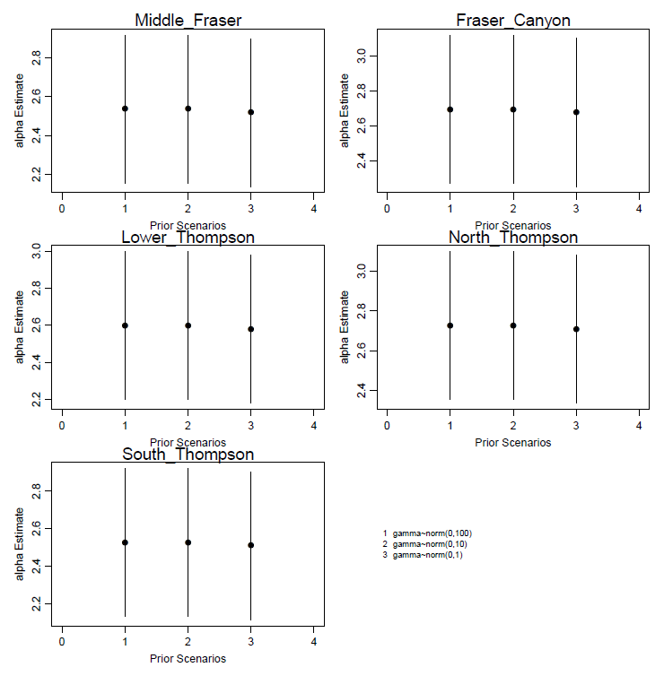

Figure 1. Comparing priors on gamma (survival coefficient)

Results were the same for $S_{gen}$ and aggregate LRP’s, with no significant changes associated with different priors on gamma. Since gamma can be positive or negative, we didn’t want to move the prior mean away from 0, which could bias the value in either direction.



Prior on global mean productivity, $μ_{α}$

Arbeider et al. assumed a normal prior distribution on µα with a mean of 1 and precision of τα = 0.5 (i.e., variance *σ*2 = 2) (Scenario 2 in Figure 2).

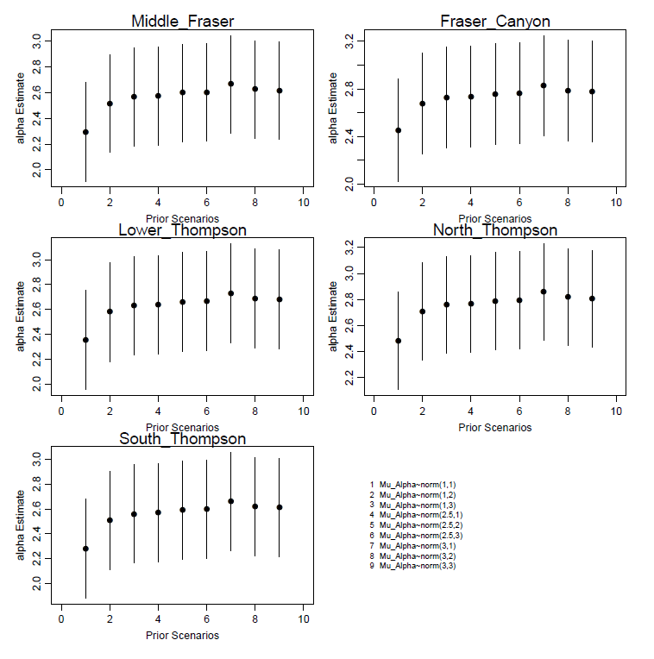

Figure 2. Prior on global mean productivity, μα

After experimenting with the priors on alpha, Brooke suggested that the mean of the prior on alpha (set at 1) may be biasing alpha values low. The first three scenarios display that when the variance on $μ_{α}$ value is small, the prior pulls the alpha values lower. When a prior mean of 2.5 is used, the alpha estimate are less sensitive to the choice of variance parameter. Based on this analysis, Brooke concluded that using a prior mean of 2.5 on $μ_{α}$ is more appropriate (Scenario 5 in Figure 2). The updated sensitivity analysis showed a similar result; however, the possible bias was very small. For now, we will continue the analysis using Brooke’s suggestion of $$μ_{α}\sim normal(μ= 2.5, σ^{2}= 2)$$

Changing the prior on $μ_{α}$, however, doesn’t have a significant effect on either estimates of $S_{gen}$ (Figure 3) or the LRP (Figure 4).



Figure 3.



Figure 4.

Prior Sensitivities on process error ($τ$) and between-CU precision in $α$ ($τ_{α}$)

These are the priors that Brooke was most concerned about when looking into this model. First, because a gamma(0.01, 0.01) distribution such as the one assumed by Arbeider et al. is extremely sparse (likely more sparse than necessary), and because two different priors were used for each precision parameter, which will likely influence how the model partitions the total uncertainty in the model between these two parameters. In the current sensitivity analysis, we examine 9 scenarios that represented different combinations of $τ$ and $τ_{α}$ prior distributions (Figure 5). Scenario 2 in Figure 5 represents what was used by Arbeider et al while Figure 5 is what we previously used for preliminary LRP results presented to the TWG in May 2020

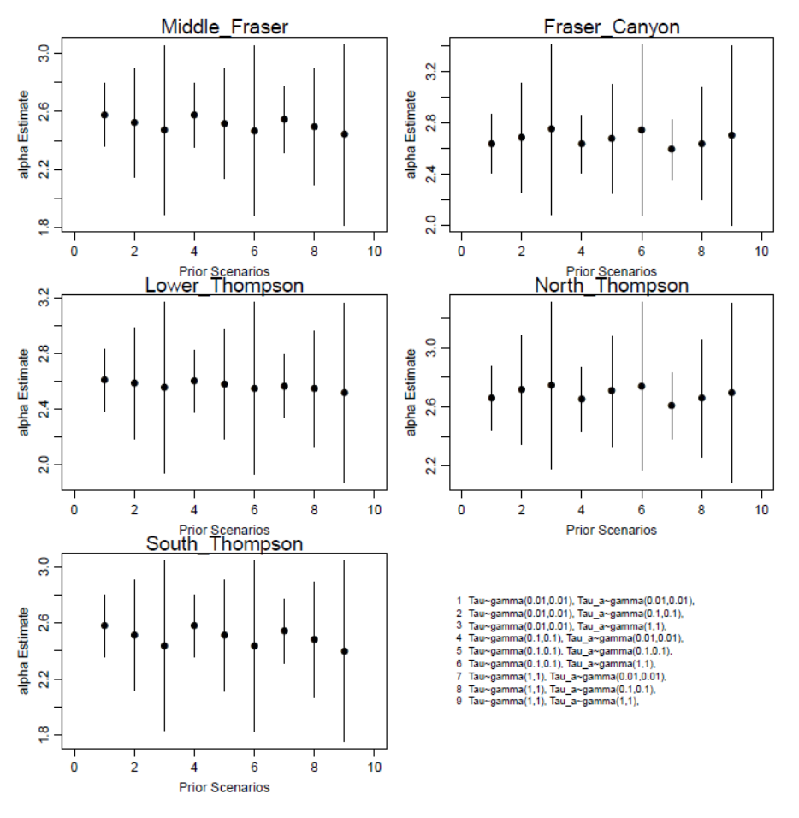

Figure 5. Prior Sensitivities on process error (τ) and between-CU precision in α (τ_α)

Estimates of CU-level alphas are quite sensitive to the choice of prior on $τ_{ α}$, and that the relationship between the two is not straight forward. When $τ_{α}$ is left more “free” (ie the longer-tailed prior is used; gamma(0.01, 0.01), scenarios 3, 6 and 9) the uncertainty around CU-level $α$’s is higher and diverge more from the CU-level mean of 2.5. The differences in the estimates of $α$ are a bit harder to interpret. The CUs on the left side of the page (Middle Fraser, Lower Thompson, South Thompson) have CU-specific $α$ values below $μ_{α}$, so are “pulled higher” by the hierarchical structure of the model. The CUs on the right (Fraser Canyon, North Thompson) have CU-specific $α$ values higher than $μ_{α}$, and therefore are “pulled lower” by the hierarchical structure of the model.

Comparing among scenarios in which the prior on $τ$ stays the same, but the prior on $τ_{α}$ changes (e.g., among scenarios 1-3, or among scenarios 4-6, etc), you can see that when $τ_{α}$ is more “free” the hierarchical structure of the model “pulls” the alpha more towards $μ_{α}$ (generally up for the CUs on the left, and down for the CUs on the right). The differences seen in lower $α$’s when $τ_{∝}$ is more “free” is harder to interpret. These priors have an overall greater effect on outcomes than previous sensitivity analyses I presented because changes in the priors have a large enough impacts on $S_{gen}$ values to actually change the final LRP estimate.

In a case like this, it is difficult to choose, and justify a choice between priors. Based on Brooke’s previous experience, she recommends that the two priors be the same – as not to bias which uncertainty parameter the model “loads” all of the uncertainty on. That narrows it down to gamma(0.01, 0.01), gamma(0.1,0.1), gamma(1, 1).

Brooke previously chose gamma(0.1, 0.1), because it is more sparse that gamma(1,1) (but not as sparse as gamma(0.01, 0.01), which she could not get to converge with the previous version of the Aggregate_LRPs_Hier_Surv.cpp file), and therefore less informative, and also because in this case it led to a more conservative final LRP. I am currently unsure what to do given the strong effect of the $τ_{∝}$ prior on LRP results. Options are:

1. Selecting gamma (0.01, 0.01) for both τ and τα– i.e., Scenario 1 in Figures 5, 6, and 7. This choice addresses Brooke’s concern about uneven productivity added to both priors, and seems most appropriate because it is the least informative. While this formulation wasn’t previously an option due to convergence priors, it seems to work fine given the updated model. This formulation leads to the lowest LRP estimates; which are lower than previously presented to TWG.
2. Selecting τ = gamma (0.01, 0.01) and τα = gamma (0.1 and 0.1) – i.e., Scenario 2. This is the same as Arbeider et al., so we could justify it this way. However, this choice is not really justified by Arbeider et al. – they point to an unpublished analysis by Parken et al. that supported the WSP Integrated Status Assessment for Interior Fraser Coho.
3. Selecting gamma (0.1, 0.1) for both τ and τα, which is what was previously recommended by Brooke. I am having trouble justifying this choice however given that we can converge with less informative priors …

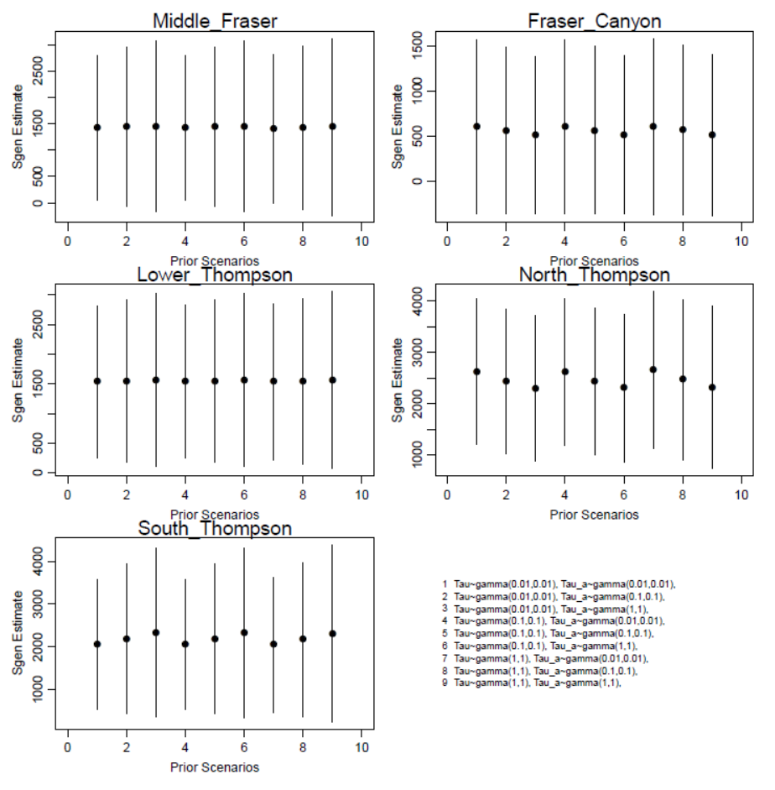

Figure 6.

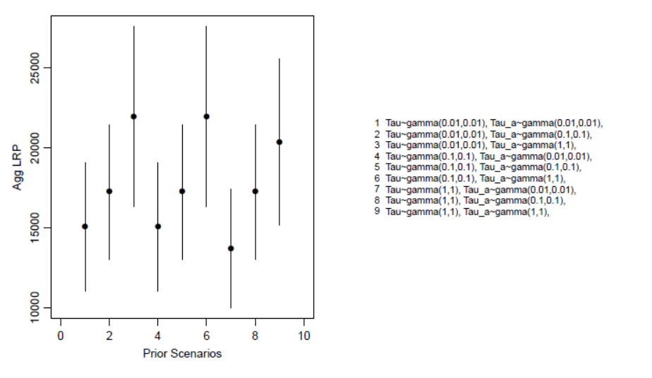

Figure 7.